Qiming Jin

12/03/2019

IT FDN 100 A Au 19: Foundations Of Programming: Python

Assignment 09

# https://github.com/QMJin/IntroToProg-Python-Mod09

# Knowledge Document

## Assignment

## Create six files in project folder: DataClasses.py, ProcessingClasses.py, IOClasses.py, TestHarness.py, Main.py, and EmployeeData.txt. Add code to each script file based on its purpose and create a main module.

## Steps

1. Use script files from the provided zip file.
2. Modify DataClasses.py, ProcessingClasses.py, IOClasses.py accordingly.
3. Create TestHarness.py to do the testing.

**if** __name__ == **"__main__"**:  
 **from** DataClasses **import** Person **as** P  
 **from** ProcessingClasses **import** FileProcessor **as** Fp  
 **from** IOClasses **import** EmployeeIO **as** Eio  
**else**:  
 **raise** Exception(**"This file was not created to be imported"**)  
  
*# Test data module*objP1 = P(**"Bob"**, **"Smith"**)  
objP2 = P(**"Sue"**, **"Jones"**)  
lstTable = [objP1, objP2]  
**for** row **in** lstTable:  
 print(row.to_string(), type(row))  
  
*# Test processing module*Fp.save_data_to_file(**"PersonData.txt"**, lstTable)  
lstFileData = Fp.read_data_from_file(**"PersonData.txt"**)  
**for** row **in** lstTable:  
 print(row.to_string(), type(row))  
  
*# Test IO classes  
#* ***TODO: create and test IO module***Eio.input_menu_options()  
print(Eio.input_menu_options())  
Eio.print_current_list_items(lstTable)  
print(Eio.input_employee_data())

1. Create a main module. Import module and include error handling.

**if** __name__ == **"__main__"**:  
 **from** DataClasses **import** Employee **as** Emp  
 **from** ProcessingClasses **import** FileProcessor **as** Fp  
 **from** IOClasses **import** EmployeeIO **as** Eio  
**else**:  
 **raise** Exception(**"This file was not created to be imported"**)

1. Write the main script. Read the data from “EmployeeData.txt” and put the data into a table.

lstFileData = Fp.read_data_from_file(**"EmployeeData.txt"**)  
**for** row **in** lstFileData:  
 lstEmployeeTable.append(Emp(row[0], row[1], row[2].strip()))

1. While it is true, print the menu and let user to input options.

**while True**:  
 Eio.print_menu_items()  
 strChoice = Eio.input_menu_options()

1. When user chooses 1, then print the current list.  
    **if** strChoice.strip() == **'1'**:  
    Eio.print_current_list_items(lstEmployeeTable)  
    **continue**
2. When user chooses 2, then add new data into the list. **elif** strChoice.strip() == **'2'**:  
    lstEmployeeTable.append(Eio.input_employee_data())  
    **continue**
3. When user chooses 3, save current data to file. **elif** strChoice.strip() == **'3'**:  
    Fp.save_data_to_file(**"EmployeeData.txt"**, lstEmployeeTable)  
    **continue**
4. When user chooses 4, exit the program. **elif** strChoice.strip() == **'4'**:  
    **break**
5. Run the script in OS command/shell window and test if it works.

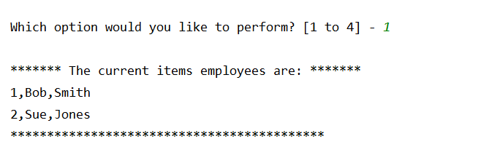

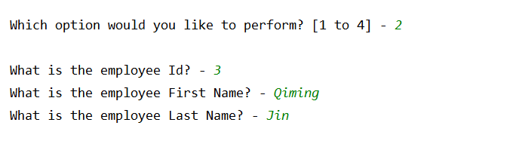

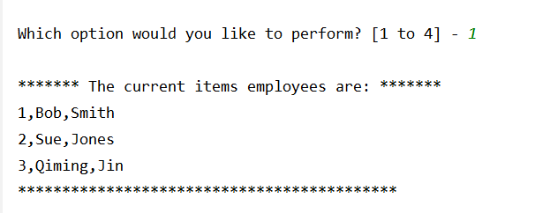

1. Check the data in text file.

